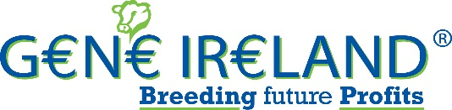

Gene Ireland Dairy Program
Sign-up Form
Year: 2019 Season: Autumn

Herd Number (the ‘Herd’):

Name: _______________________________________ (the ‘Herd Owner’)

Mobile: ________________________________________

Cost: €8.50 per straw

Tick relevant box for number of straws
Dairy Packs: 24 30
Holstein-Friesian:

3 Pedigree registered bulls:
Test straws are available in packs of 24 (3 bulls x 8 straws) and 30 (3 bulls x 10 straws).

AI DETAILS

AI Service Provider:

DIY Technician

Name of Sales Rep (DIY herds) / AI Technician:

AI start date:

General:
I/We apply to participate in the Program as a progeny test herd. I/We accept and agree to comply with and to be bound by the Conditions of the Program.

Signature: _____________________________ Date: __________________

Send to: G€N€ IR€LAND®, ICBF, Highfield House, Bandon, Co Cork.
Any questions you may have, please call ICBF on 023 8820452

