BDGP II Help Sheet

What is the purpose of the programme?
To improve the sustainability of the national suckler herd by improving the genetic merit for key profit traits such as cow milk and fertility. This will in turn make the national suckler herd more carbon efficient by increasing calves per cow per year (more calves weaned per 100 cows) and increasing calf growth rates (cows weaning heavier calves through increased milk production). A more carbon efficient suckler herd will, therefore, be beneficial to our environment and will also deliver significant economic benefits to farmers over time.

What makes an efficient suckler cow?
Regardless of breed and cow type, there are some basic targets which a suckler cow should meet. She should:
- Calve for the first time at approximately 24 months (22-26 months).
- Calve every 365 days thereafter.
- Have enough milk to rear a good quality calf each year.
- Be docile and functionally sound.
- Remain in the herd for five or more calvings.

What is the €uro-Star Replacement index?
The €uro-Star Replacement Index estimates how suitable a cow or heifer will be for overall suckler cow profitability. It takes into account the most important traits for a suckler cow including: calving traits, milkability, fertility, docility, maintenance costs and progeny performance. Breeding from the highest Replacement Index stock will help farmers to achieve the suckler cow targets outlined above. The Replacement Index should be used where a farmer wants to select or breed replacement heifers.

What do the Stars represent?
The stars rank animals on their €uro-Star Index. They help to make the indexes easier to understand e.g. a 5 star animal on the Replacement Index is in the top 20% of the national herd, while a 1 star animal on the Replacement Index is in the bottom 20%. Table 1 provides a break-down of the €uro-Star indexes across the five star categories.
Table 1. Breakdown of the €uro-Star indexes across the five star categories.
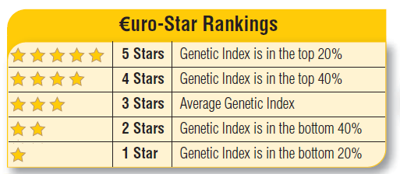

Do the €uro-Star indexes work?
Latest work from Teagasc and ICBF has indicated that selecting animals based on the €uro-Star Replacement Index will result in more profitable, sustainable herds. Trends from the ICBF database clearly indicate that herds with a high replacement index (i.e., more 4/5 star cows in their herds), have more calves per cow per year than low replacement index herds.

What is the benefit of genotyping?
Having information on the animals genotype allows ICBF provide a more accurate picture of the expected profitability of a given animal. The genotype data is used in addition to existing data on parentage, close relatives and the animals own performance.

What is the cost of genotyping and what will my net annual payment be?
The cost of genotyping is only €22 per animal. Some 60% of a herd’s reference animals will be genotyped each year, with this amount deducted prior to payment.

I have animals with no stars on my BDGP €uro-Star Report?
The most common reason for an animal not having stars is because it has no sire recorded (missing sires). Some animals with missing sires may have a €uro-Star Index; these are most likely older suckler cows where data has been recorded on their progeny.
- Where missing sires are known they can be recorded online at www.icbf.com.
- Where missing sires are not known, genotyping may find the correct sire.
Any new sires recorded on animals will be routinely checked by ICBF against DNA records to avoid any inaccuracies in data.

