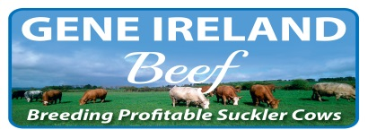

2017 Beef Sign-up Form
Herd Number:

Name: ________________________________________

Mobile: ________________________________________

PROGRAMME DETAILS

Year: 2017 Season: Summer
Cost: €5 per straw.
Please don’t send payment with this order form. Your nominated AI service provider will invoice you for the straws.
(Please fill in your order details below)

AI Code Number of Straws (minimum 5 per bull)

1. ___________
2. ___________

3. ___________

n/a n/a
4. ___________
5. ___________

AI DETAILS

AI Service Provider:

DIY Technician

Name of Sales Rep or Technician: ____________________________

General:
- I agree to the G€N€ IR€LAND® terms and conditions (available on the ICBF website). I understand that they apply to this order and I agree to be bound by them.

Signature: _____________________________ Date: __________________

Return to: ICBF, Highfield House, Bandon, Co Cork.
Any questions you may have, please call ICBF on 023 8820452 or 045 521573

