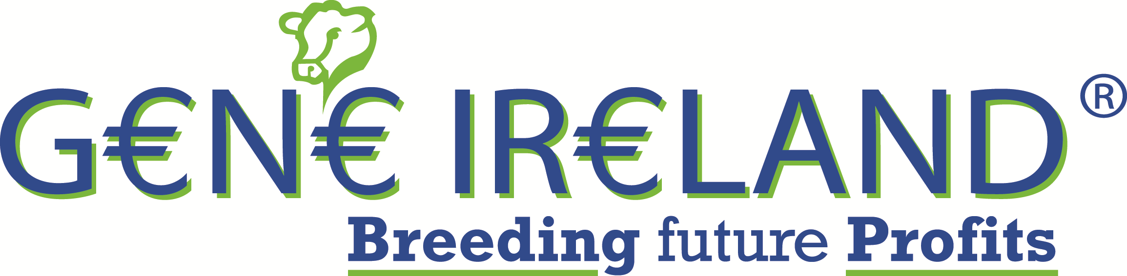

Spring 2016 G€N€ IR€LAND® Dairy Programme

- This spring our target is to test 70 High EBI young bulls. Genomic data is used in the bull selection process. Pedigree herds will receive all pedigree bulls.
- The cost is €8.50 per straw.
- All Herds who use Gene Ireland bulls are expected to participate fully in recording all relevant data e.g., inseminations, milk recording, fertility, health and disease events etc.
- Excellent customer support is provided including inbreeding reports for your herd, test bull information sheets & on-line G€N€ IR€LAND® reports and profiles.

BREED PACKS AND EXPECTED EBI’S ARE AS FOLLOWS:

- Holstein-Friesian: Expected EBI = €374
- Pure Friesian : Expected EBI = €269
- Multi-breed: Expected EBI = €290
The Multi-breed pack is a combination of Jerseys, HF x JE crossbreds and HF bulls for comparative purposes.

Test straws are available in packs of 25 (5 bulls x 5 straws) 35(5 bulls x 7 straws) and 50 (5 bulls x 10 straws). Enclosed you will find a sign-up form, potential bull lists and a return envelope. Details of the potential bulls are available in the G€N€ IR€LAND section of the ICBF website.

2016 Dairy /Beef Programme
Straws from Beef bulls suitable for use in dairy cows will be available to interested herds.
To receive more information please indicate on the enclosed sign-up form or ring ICBF.

If interested in joining the programme(s) this spring, it is advisable to do one of the following as soon as possible as demand is high.

- Complete the enclosed Sign-up Form and return in the FREEPOST envelope provided.
- Ring ICBF on 1850 600 900 to sign up over the phone.
- Text the word BULL to 089-4577663 for a call-back, or Contact your local Semen Sales advisor.

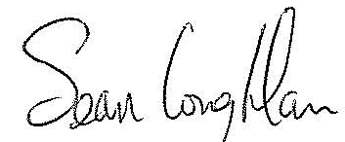
Yours sincerely,
Sean Coughlan,
Chief Executive
Irish Cattle Breeding Federation
On behalf of all participating organizations
Irish Cattle Breeding Federation Society Ltd. Registered Office: Highfield House, Shinagh, Bandon, Co Cork.

Registered Dublin, Ireland, # 4914

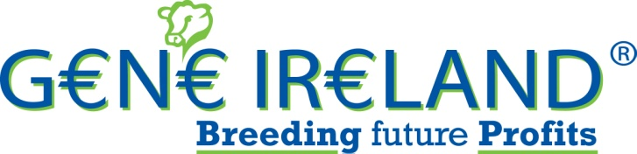

Dairy G€N€ IR€LAND® Sign-up Form Spring 2016
Herd Designator:
I | E

Name: ________________________________________

Mobile: ________________________________________

PROGRAMME DETAILS- Cost €8.50 per straw.

Year: 2016

Season: Spring

Number of Straws (Maximum 50) (This applies to the Dairy Packs).
(Tick relevant box for breed & number of straws)
Dairy Packs: 25 35 50
Holstein-Friesian:
Pure Friesian (3 bulls in pack)
Multi-Breed*
n/a n/a

*(Multi-breed pack contains HF bulls, JE bulls and HF x JE crossbred bulls)

DAIRY BEEF PACK: Please tick box if interested in a call back.

AI DETAILS

AI Service Provider:

DIY Technician

Name of Sales Rep or Technician: ____________________________

AI start date:

General:
- I agree to the G€N€ IR€LAND® terms and conditions (available on the ICBF website). I understand that they apply to this order and I agree to be bound by them.

Signature: _____________________________ Date: __________________

Send to: G€N€ IR€LAND®, ICBF, Highfield House, Bandon, Co Cork.
Any questions you may have, please call ICBF on 1850 600 900

