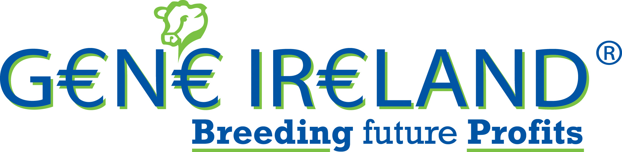

2015 Beef Sign-up Form
Herd Designator:
I | E

Name: ________________________________________

Mobile: ________________________________________

PROGRAMME DETAILS

Year: 2015 Season: Summer

Cost €5 per straw.
Please don’t send payment with this order form. Your nominated AI service provider will invoice you for the straws.
(Please fill in your order details below)

AI Code Number of Straws (minimum 5)

1. ___________
2. ___________

3. ___________

n/a n/a
4. ___________
5. ___________

AI DETAILS

AI Service Provider:

DIY Technician

Name of Sales Rep or Technician: ____________________________

General:
- I agree to the G€N€ IR€LAND® terms and conditions (available on the ICBF website). I understand that they apply to this order and I agree to be bound by them.

Signature: _____________________________ Date: __________________

Return in the FREEPOST envelope to: G€N€ IR€LAND®, ICBF, Highfield House, Bandon, Co Cork.
Any questions you may have, please call ICBF on 1850 600 900 or 045 521573

